ParishStaq Portal Administration
Best Practices & Responsibilities

The ParishStaq Portal is a web-based integration tool that connects external systems with the ParishStaq Database. Parish-level administrators can use the Portal to review and maintain parish data, identify potential duplicate profiles, run reports, manage staff contact information, and monitor overall data health.

Parish Admins Can Use the Portal To:
- Manage parish contacts: Use the People CRM to maintain an internal list of parish staff and contacts.
- Review NCOA updates: Receive and manage National Change of Address (NCOA) updates to help keep parishioner addresses current.
- Review potential duplicates: Use advanced filters to identify potential duplicate profiles and export duplicate records for further review.
- Visualize parishioner locations: Use the Parish Family Map to identify geographic trends and better understand where parishioners and parish families are located within the community.

People

- Use as a Contact Resource
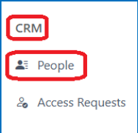
The People section functions as an internal CRM for maintaining a current
list of contacts and staff at each parish. When you need to connect with
staff at another campus, use this resource to find their current contact
information and roles.

- Keep Staff Roles Up to Date
The PES team works to maintain accurate staff contact and role information
across campuses. If you become aware of a change to your campus staff
or their role, please contact ParishStaq Support at
support@archdioceseofseattlepes.samanage.com.

Keeping this information current helps ensure that staff across campuses have access to the most up-to-date contact and role information.

Dedupe – Self Service

The Dups – Self Service tool allows parish administrators to review potential duplicate profiles within their parish family and access the corresponding ChMS profiles for review and merging.

- Open Dups – Self Service
From the ParishStaq Portal landing page:

- Navigate to the left-hand menu and select Dups – Self Service
- Input the following filters to populate potential duplicates for your selected parish:

- Scan Type: All scan types (combined)
- Confidence: All
- Status: All
- Scope: Constrained to Selected Campus

- Select Apply to populate the list of potential duplicates. You can also select Export CSV in the upper-right corner to download the results for further review.

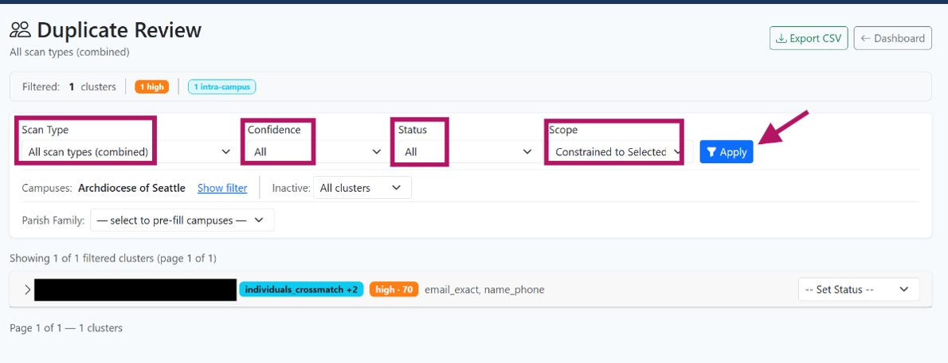

- Select a Profile to Review
Under Name, the individual's name will appear as a clickable link in blue. Select the name to open the parishioner's ChMS profile in a new tab.

Review the profiles and complete the merge using standard deduplication best practices. Before merging, verify that the profiles belong to the same individual and that the resulting profile contains the most accurate and complete information.

For detailed instructions, see the Pushpay Help Article: Pushpay Help Article - How to merge ChMS profiles

- Update the Duplicate Status
After completing the merge, return to the ParishStaq Portal and use the Set Status dropdown to update the duplicate record.

Status | Description
In Progress | The appropriate action is still being determined, or additional information or confirmation is needed
Completed (Merged) | The duplicate profiles have been successfully merged
Not a Duplicate | The profiles were reviewed and determined to be different individuals
Clear Status | The duplicate record is no longer available (typically because the profiles have already been merged or a profile has been removed)

NCOA Address Changes

The NCOA process helps parishes identify and manage address changes and address standardization updates for parishioners.

- Enable NCOA Request Notifications
To register your parish for NCOA notifications, contact ParishStaq Support at support@archdioceseofseattlepes.samanage.com and provide the following information for each parish:

- Notification emails should go to these people -
- Approval permissions should be set to this person -
- Address changes (a parishioner has moved) - Set these to Automatic or Manual?
- Address improvements (capitalization, ZIP+4, standardization) - Set these to Automatic or Manual?

Parish Family Map

- Visualize Engagement using the Parish Family Map

From the ParishStaq Portal landing page, navigate to Location Reports in the left-hand menu and select Parish Family Map.

The Parish Family Map provides a visual representation of where parishioners and parish families are located within your community. The interactive map can help parish staff identify geographic trends and better understand where parishioners are concentrated across the parish family.
Using the heat map feature, you can also identify areas with higher concentrations of parishioners.

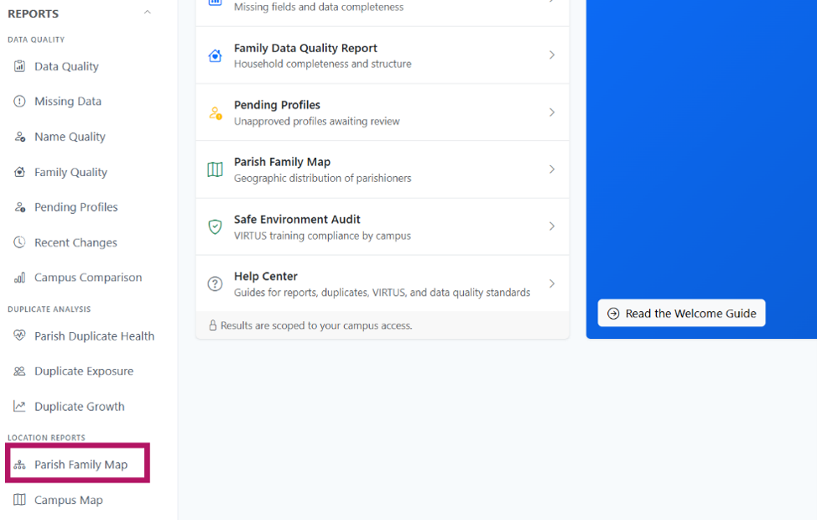

For More Assistance and Training

For additional ParishStaq resources, training materials, and support, please visit the ParishStaq Resources Page.

For foundational training on ParishStaq, see the ParishStaq Essentials Course information on the Resources page. Access to the course is provided upon request; please contact PES Support to request enrollment.

