Forms Management
Best Practices & Responsibilities

From collecting information through registrations and processing gifts, forms are one of the primary ways that information enters Parishstaq. Properly configured and maintained forms help ensure that user information is captured correctly, and staff can follow up with parishioners who engage with the parish. Form Managers have a responsibility to maintain all forms in their control. The following outlines their primary responsibilities:

Form Creation
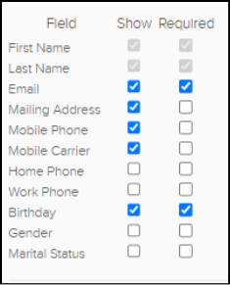
- Create New Form or Use a Template
Create a new form if you need to build one from scratch. If you anticipate reusing a
form or creating similar forms in the future (e.g., registrations), consider creating a
template that can be accessed by you and your campus.

Before creating your own form, review the existing Archdiocese templates. These
provide a starting point and can be customized to meet your parish’s needs.

Available templates include:
- Parishioner Registration
- Event Sign-Up
- Stewardship and ACA
- Announcement Requests
- Payment Forms
- Sacrament Information
- Partners in the Gospel-related forms, ready to deploy to your intended audience

- Use clear naming conventions
When creating a form on a campus, use good naming conventions so that a form’s
purpose can be derived from the name.

- Include sufficient contact information
***Forms without sufficient information are the profiles that typically end up in pending or duplicates. Use contact fields that help ParishStaq as a system identify and match the respondent to an
existing profile. At minimum, include the recommended Contact fields:

- Full Name
- Email
- Phone Number
- Mailing Address

* If a form is configured as a Requires Login form, only collect additional personal
information when it is required for the process. Logged-in users are already identified through their account.

Review Form settings
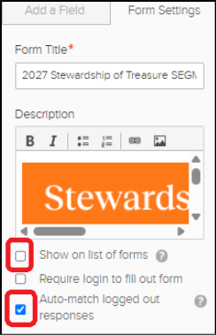
- UNCHECK the Form Setting for ‘Show on list of forms’
The public list of forms can be accessed by anyone with the link, both within and
outside the archdiocese. Unchecking this setting helps ensure that the form is only
accessed through the link shared directly with your intended parish audience.

- CHECK the Form Setting for ‘Auto-match logged out responses’
This allows the system to automatically match form submissions to an existing
profile when applicable. Form Automations ONLY work when a response is
matched to a profile.

- Customize the confirmation message
Provide the respondent with relevant information or next steps after they submit
the form.

Consider:
- A Custom Message
- A Custom URL Redirect, such as a relevant page on the parish website

*Public Pages are generally not recommended.

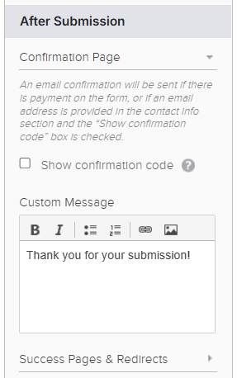
After Submission

- Unpublish and Archive the form (if needed)
This keeps the active form list manageable and helps prevent outdated forms
from continuing to collect information.

- Review responses regularly (weekly or more frequently)
Review each of your active forms on a weekly basis and ensure that all form
responses are MATCHED to a profile in the ChMS.

If a respondent does not have an existing profile, create a profile using the steps
outlined in the Pushpay Help Article - Form Responses.

When creating a new profile, be sure to complete the following fields:

- Family/Household Mailing Name (About tab)
- Family Informal Salutation (About tab)
- Membership Type (Admin tab)
- Membership Start Date (Admin tab)

- Coordinate with your Financial Admin on Form Payments (weekly or more frequently)
Please ensure your Financial Admin is completing the following two steps:

- Go to Giving → Forms in the ChMS - Match any Form Payments that have not automatically matched to an existing profile.
- Go to Giving → Forms in the ChMS - Create batches for the Form Payment transactions in the ChMS.

For More Assistance and Training

For additional ParishStaq resources, training materials, and support, please visit the ParishStaq Resources Page.

For foundational training on ParishStaq, see the ParishStaq Essentials Course information on the Resources page. Access to the course is provided upon request; please contact PES Support to request enrollment.

