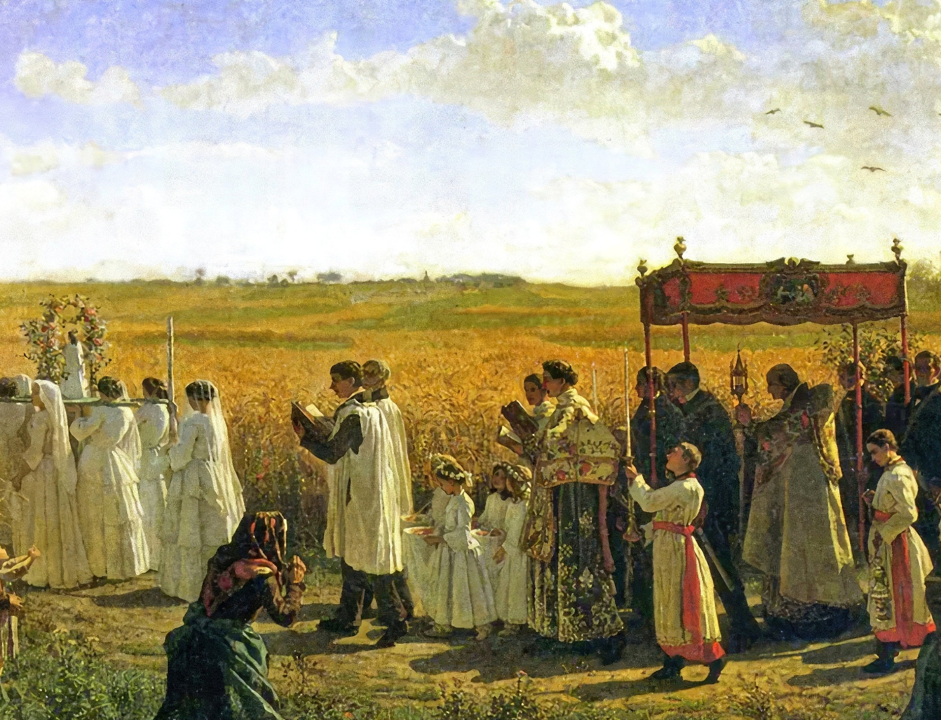

HORA SANTA por las VOCACIONES/
HOLY HOUR for VOCATIONS

Himno de exposición/Exposition hymn O salutaris hostia
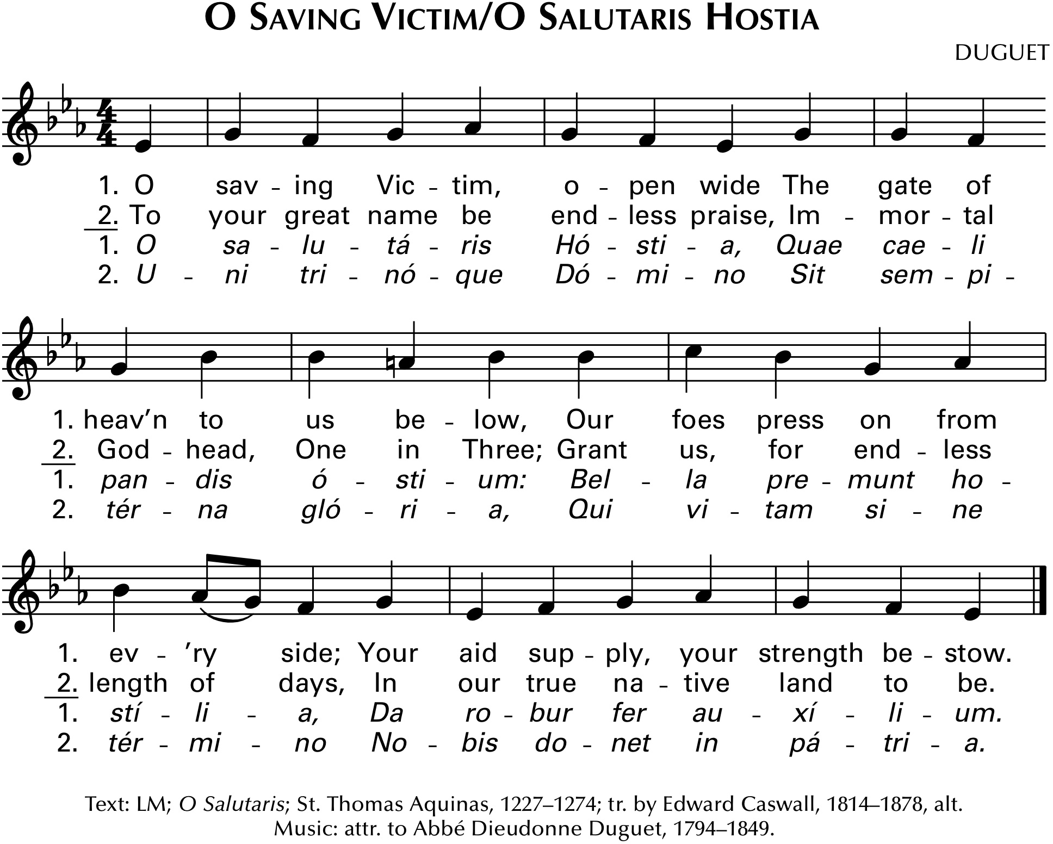

Oración inicial/Opening prayer

Adoración al Santísimo Sacramento/
Adoration of the Blessed Sacrament

Cover art: The Blessing of the Wheat in Artois, Jules Breton, c. 1857.
Music reprinted with permission under OneLicense #A721493.
ADORACIÓN AL SANTÍSIMO SACRAMENTO/
ADORATION OF THE BLESSED SACRAMENT
Pasaje bíblico sugerido para orar/
Suggested scripture passage to pray with (Matthew 9:35-38)
Jesús recorrió todos las y pueblos y aldeas enseñando en sus sinagogas, proclamando el evangelio del reino y sanando toda enfermedad y toda dolencia.
Al ver las multitudes, se compadeció de ellos porque estaban afligidos y desamparados, como ovejas sin pastor.
Entonces dijo a sus discípulos: «La cosecha es abundante, pero los obreros son pocos. Pidan, pues, al dueño de la cosecha que
mande obreros a su cosecha».
Jesus went around to all the towns and villages, teaching in their synagogues, proclaiming the gospel of the kingdom, and curing
every disease and illness.
At the sight of the crowds, his heart was moved with pity for
them because they were troubled and abandoned, like sheep without
a shepherd.

Then he said to his disciples, “The harvest is abundant, but the
laborers are few; so ask the master of the harvest to send out laborers for his harvest.”

Lectura de las Escrituras/Reading of Scripture (Jeremiah 29:11-14)
Pues yo sé los planes que tengo para ustedes, planes de bienestar,
no de desgracia, para darles un porvenir de esperanza. Me invocarán
y volverán a mí, y yo los escucharé. Me buscarán y me encontrarán, cuando me busquen de todo corazón. Yo me desaré hallar por ustedes
y cambiaré su suerte, los reuniré de entre todas las naciones y de
todos los lugares a donde los haya arrojado, y los haré regresar al
lugar de donde los he desterrado.
For I know well the plans I have in mind for you, plans for your welfare and not for woe, so as to give you a future of hope.
When you call me, and come and pray to me, I will listen to you.
When you look for me, you will find me. Yes, when you seek me with
all your heart,
I will let you find me, and I will change your lot; I will gather you together from all the nations and all the places to which I have banished you, and bring you back to the place from which I have exiled you.

Sweet Sacrament (The Vigil Project)
Jesus, My Lord, My God, My All. Refrain:
How can I love Thee as I ought? Sweet sacrament, we Thee adore
and how revere this wondrous gift O make us love Thee more and more.
so far surpassing hope or thought? (refrain)

Had I but Mary’s sinless heart
To love Thee with, my dearest King.
O with what bursts of fervent praise.
Thy goodness, Jesus, would I sing. (refrain)

Sound, sound his praises higher still
and come, ye angels, to our aid.
‘Tis God, ‘Tis God the very God.
Whose power both man and angels made. (refrain)

BENDICIÓN DEL SANTÍSIMO SACRAMENTO/
BENEDICTION OF THE BLESSED SACRAMENT
Himno de bendición/Benediction hymn
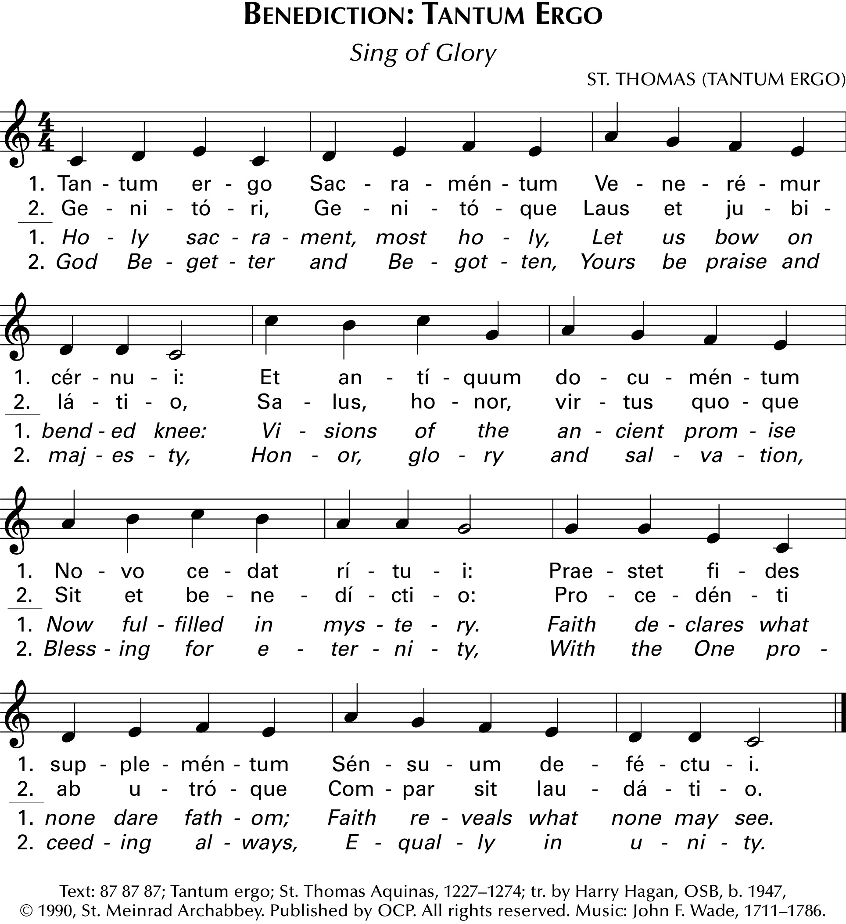

Versículo/
Verse Presider: Les has dado Pan del cielo/
You have given them Bread from heaven.
All: Que tiene en sí todo deleite./
Having all sweetness within it.

Las Divinas Alabanzas/Divine Praises
Bendito sea Dios.
Bendito sea Su Santo Nombre.
Bendito sea Jesucristo, Dios verdadero y hombre verdadero.
Bendito sea el Nombre de Jesús.
Bendito sea Su Sagrado Corazón.
Bendita sea Su más Preciosa Sangre.
Bendito sea Jesús en el más Sagrado Sacramento de el Altar.
Blessed be the Holy Spirit, the Paraclete.
Blessed be the great Mother of God, Mary most holy.
Blessed be her Holy and Immaculate Conception.
Blessed be her Glorious Assumption.
Blessed be the Name of Mary, Virgin and Mother.
Blessed be St. Joseph, her most chaste spouse.
Blessed be God in his angels and in His Saints.

Reposición del Santísimo Sacramento/
Reposition of the Blessed Sacrament
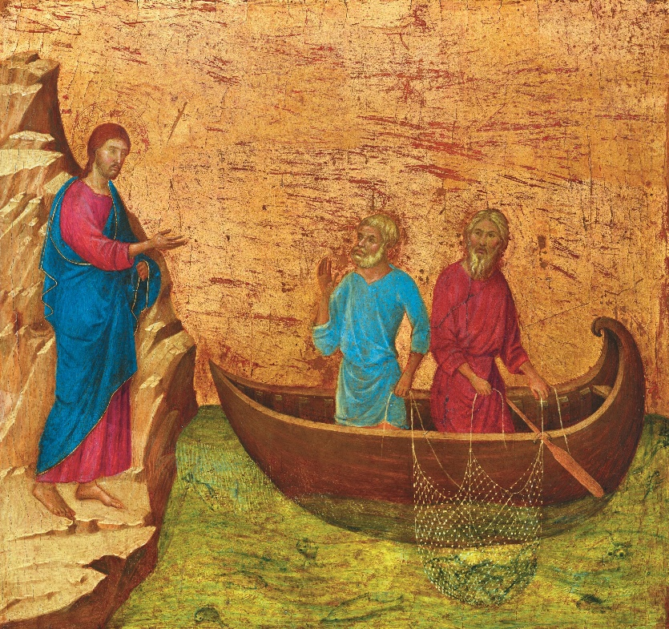
Calling of the Apostles Peter and Andrew, Duccio di Buoninsegna, c. 1308-1311

Himno de fin de oficio/Recessional
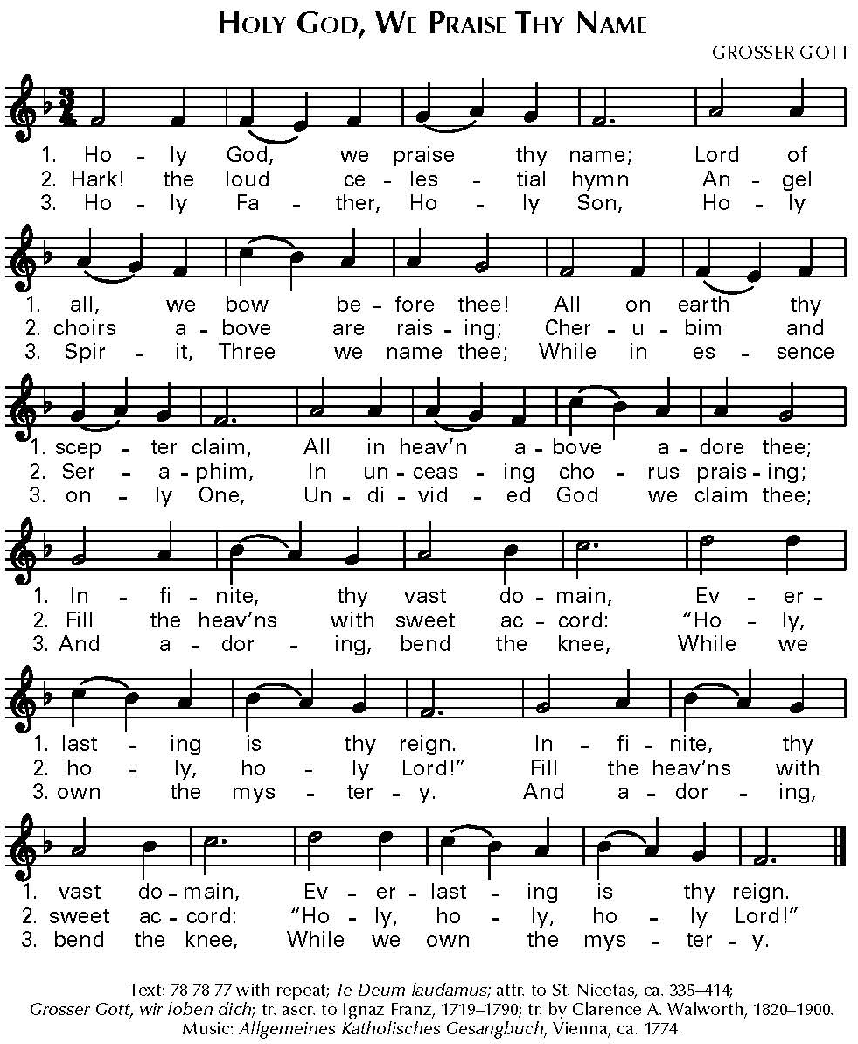

La Custodia que se utilizará para esta Hora Santa es la custodia de vocaciones de la
Oficina de Vocaciones. Oremos por las vocaciones al sacerdocio, al diaconado y a la vida
religiosa de nuestras familias parroquiales y de nuestra arquidiócesis.
The Monstrance being used for this Holy Hour is the vocations monstrance from
the Vocations Office. Let us pray for vocations to the priesthood, diaconate,
and religious life from our parish families and our archdiocese.

Oración arquidiocesana por las vocaciones/
Archdiocesan prayer for vocations
Señor Padre nuestro,
Tú nos llamas a cada uno
a utilizar sus dones en el Cuerpo de Cristo.
Inspira a tu pueblo
con el deseo de conocerte,
la gracia de comprender tu voluntad
y, con la fuerza del Espíritu Santo,
el valor para responder
con amor y libertad.
Envía trabajadores a tu gran cosecha
para que el Evangelio sea predicado, los pobres
sean servidos con amor y sean consolados,
y para que tu pueblo sea fortalecido por los sacramentos.
Te pedimos esto en nombre de Cristo, Nuestro Señor. Amén.

God our Father,
You call each of us
to use our gifts in the Body of Christ.

Inspire your people
with desire to know you,
the grace to understand your will,
and, with the strength of the Holy Spirit,
the courage to respond
with love and freedom.

Send workers into your great harvest
so that the Gospel is preached, the poor
are served with love, the suffering are comforted,
and your people are strengthened by the sacraments.
We ask this through Christ our Lord. Amen.

