Post Payroll Reports for Journal Entry
Go to report center
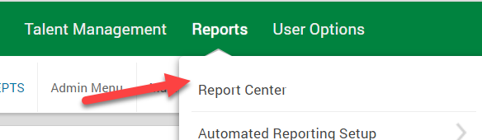
On the left side of screen choose client inbox reports.
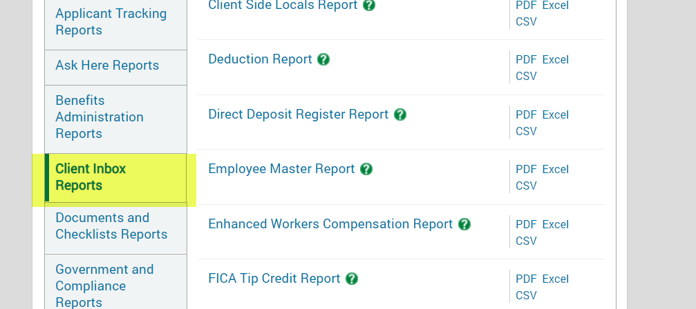
In the list of reports generate select the payroll distributed summary report.
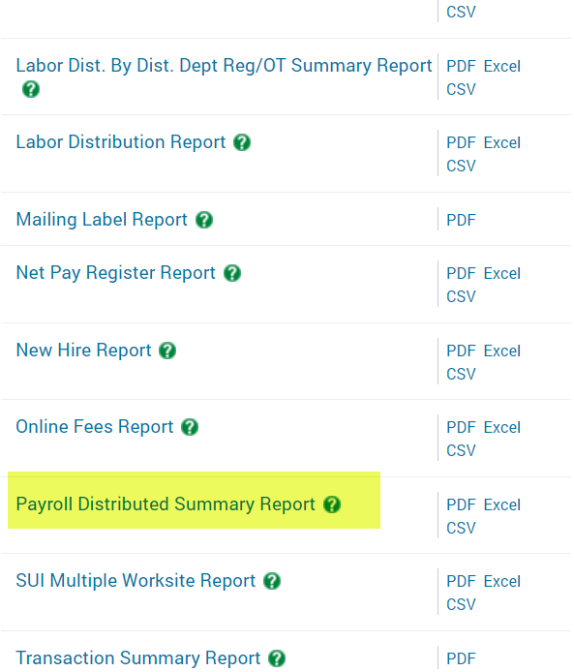
Then you can select the following options.
- Select PDF
- Select historical transactions
- Choose the check date your employees were paid and 0TT54.
- Select Summary
- Group by – you choose whatever option you would like here. This will give the report to you breaking out by totals for each department (or whatever you choose)

