How to Generate the Payroll Sweep Report
Go to Report Center and Saved Reports: search for payroll sweep report and click on load.
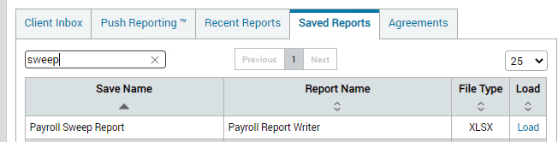
In the highlighted fields, enter the pay date, then click on generate report.
