Payroll Preview Report
Now in Paycom instead of waiting for the payroll office to generate your payroll preview, you will be able to generate this on your own. To do so, follow these steps.
- Go to Reports > Report Center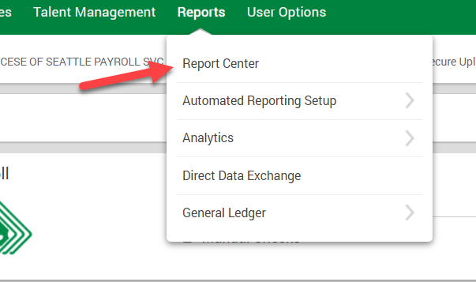
- Next, click on the saved reports tab, and click load for the PAA Payroll Preview Report. 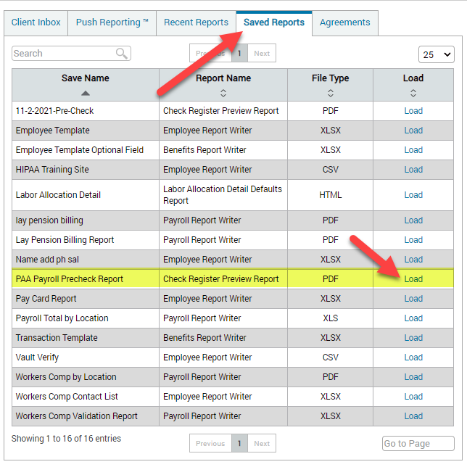
- Then select the highlighted options and ensure the current transaction has the check date you are reviewing selected. Once you have chosen the necessary options click on generate report. 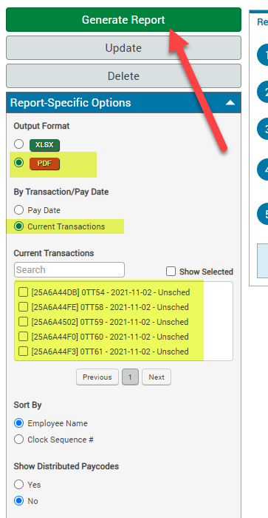
- After review the report, notify the Payroll Services office if any changes are needed or that the reprot is accurate. If changes are needed, wait for email confirmation that changes have been made and re-run the report to confirm. Once accurate rpeort is confirmed, email the Payroll Services Office that no further changes are needed.

