CRS Rice Bowl and the USCCB’s Catholic Relief Services Collection (CRS Collection)
During Lent, Catholics in the United States have two opportunities to support the Church’s global mission to assist the poor.
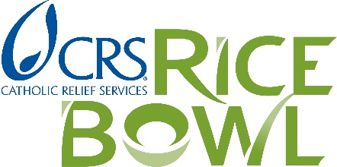  CRS Rice Bowl | 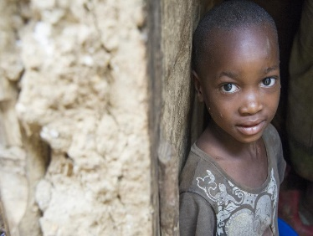  CRS Collection
What is it?
CRS Rice Bowl is Catholic Relief Services’ Lenten faith-in-action program for families and faith communities. It offers simple, yet powerful, ways for every one of our parishes, most of our schools, and families throughout western Washington to bring Lenten spirituality to life.  Every Lent, Catholics here and throughout the U.S. do something amazingly holy and just. Our prayers, fasting and almsgiving become lifesaving aid for millions of individuals living in conditions of poverty around the world. The hungry are fed; the thirsty are given drink; immigrants and refugees are served; the homeless find shelter. | The CRS Collection is one of the twelve national collections established by the bishops of the United States and represents our community of faith at work in the world. The CRS Collection theme, Help Jesus in disguise, reminds us of the presence of Christ in every one of our brothers and sisters in need.  The bishops encourage us to view the national collection in the light of stewardship and sharing. It is right and just that we give something back, helping people in our nation and worldwide to live better and grow in the love of Jesus.
When does it happen?
Rice Bowl begins on Ash Wednesday, February 17, 2021 and ends with Easter Sunday, April 2, 2021 | The national date for the CRS Collection is always Laetare Sunday, the fourth Sunday of Lent. This year, the CRS Collection lands on March 13, 2020.
Who Benefits?
Rice Bowl contributions support projects that assist our sisters and brothers in need, both overseas and here in the United States. 75 percent of Rice Bowl contributions are sent to Catholic Relief Services and help fund development projects overseas that help increase and maintain communities’ access to food. 25 percent of the contributions fund local poverty and hunger alleviation programs in dioceses in the U.S. Visit www.seattlearchdiocese.org/ricebowl to learn how we use the 25% in this archdiocese through our Rice Bowl grants program. No administrative expense is taken out of your donation. (Every parish is encouraged to apply for a grant!) | The CRS Collection supports six Catholic organizations (Catholic Relief Services; the U.S. Conference of Catholic Bishops’ Department of Justice, Peace, and Human Development; Migration and Refugee Services, its Catholic Legal Immigration Network Inc., its Secretariat for Cultural Diversity in the Church; and the Holy Father’s Relief Fund) that advance the international social ministry of the Catholic Church. Visit www.usccb.org/catholic-relief to find more information about who benefits from our support.

If you have any questions, please contact the Annual Campaigns Office at 206-382-3484 or via email at elijah.morgan@seattlearch.org.

