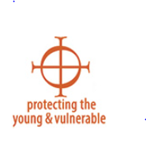

Feedback: Your feedback is important to our office. We want to ensure all questions are being answered and that you have the opportunity to tell us how we can improve. Please feel free to fill out the information below. You can scan, email or fax this form back to the Safe Environment Office.

Questions:

What can be improved?

Clarification?

Other comments?

