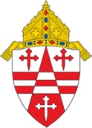

CATHOLIC ARCHDIOCESE OF SEATTLE

Affidavit for the Parent or Sponsor of a Baptized Child

I, ___________________________________________________________________, attest that
__________________________________________________________ was baptized according to the rites of the Roman Catholic Church on the _________ day of __________________ in the year________ at the Church/chapel of ______________________________________________
in the city/town of ______________________________________________________________,
by the Rev. ____________________________________________________________________.
I know this because I am:
_____ a parent
_____ a sponsor
_____ a person present at the ceremony
_____ the minister of baptism

Signature and date: ____________________________________________________________________
Witness and date: ______________________________________________________________________

Return this form with any relevant photographs or video footage to the parish of baptism. Staff will enter the sacramental information into their register and issue a certificate to you.

